**Chapter 5**

**Sequences and Series**

**5.2 Infinite Series**

**Section Exercises**

**Using sigma notation, write the following expressions as infinite series.**

67. 

Answer: 

69. 

Answer: 

**Compute the first four partial sums  for the series having  term  starting with  as follows.**

71. 

Answer: 

73. 

Answer: 

**In the following exercises, compute the general term  of the series with the given partial sum  If the sequence of partial sums converges, find its limit **

75. ,

Answer:  Series converges to 

77. 

Answer:  Series diverges because partial sums are unbounded.

**For each of the following series, use the sequence of partial sums to determine whether the series converges or diverges.**

79. 

Answer:   In general  Series diverges.

81.  (*Hint:* Use a partial fraction decomposition like that for 

Answer:  





The pattern is  and the series converges to 

**Suppose that  that  that  and  Find the sum of the indicated series.**

83. 

Answer: 

85. 

Answer: 

**State whether the given series converges and explain why.**

87.  (*Hint:* Rewrite using a change of index.)

Answer: diverges, 

89. 

Answer: convergent geometric series, 

91. 

Answer: convergent geometric series, 

**For  as follows, write the sum as a geometric series of the form  State whether the series converges and if it does, find the value of **

93.  and  for 

Answer:  converges to 

95.  and  for 

Answer:  converges to 

**Use the identity  to express the function as a geometric series in the indicated term.**

97.  in 

Answer: 

99.  in 

Answer: 

**Evaluate the following telescoping series or state whether the series diverges.**

101. 

Answer:  as 

103. 

Answer:  diverges

**Express the following series as a telescoping sum and evaluate its *n*th partial sum.**

105. 

Answer: 

107. 

Answer: and 

**A general telescoping series is one in which all but the first few terms cancel out after summing a given number of successive terms.**

109. Let  in which  as  Find 

Answer: 

111. Suppose that  where  as  Find a condition on the coefficients  that make this a general telescoping series.

Answer: 

113. Evaluate 

Answer:  

115. **[T]** Define a sequence  Use the graph of  to verify that  is increasing. Plot  for  and state whether it appears that the sequence converges.

Answer:  converges to  is a sum of rectangles of height  over the interval  which lie above the graph of 

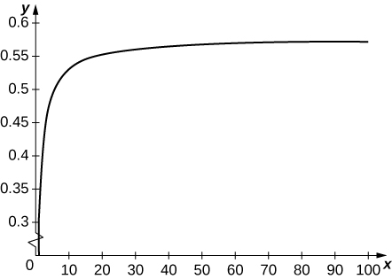

**Each of the following infinite series converges to the given multiple of  or **

**In each case, find the minimum value of  such that the  partial sum of the series accurately approximates the left-hand side to the given number of decimal places, and give the desired approximate value. Up to  decimals place, **

117. **[T]**  error 

Answer: 

119. **[T]**  error 

Answer:  

121. [**T]** A fair coin is one that has probability  of coming up heads when flipped.

* 1. What is the probability that a fair coin will come up tails  times in a row?
  2. Find the probability that a coin comes up heads for the first time after an even number of coin flips.

Answer: a. The probability of any given ordered sequence of outcomes for  coin flips is  b. The probability of coming up heads for the first time on the th flip is the probability of the sequence  which is  The probability of coming up heads for the first time on an even flip is  or 

123. **[T]** Find the probability that a fair coin will come up heads for the second time after an even number of flips.

Answer: 

125. **[T]** The expected number of times that a fair coin will come up heads is defined as the sum over  of  times the probability that the coin will come up heads exactly  times in a row, or  Compute the expected number of consecutive times that a fair coin will come up heads.

Answer: as can be shown using summation by parts

127. [**T]** Suppose that the amount of a drug in a patient’s system diminishes by a multiplicative factor  each hour. Suppose that a new dose is administered every  hours. Find an expression that gives the amount  in the patient’s system after  hours for each in terms of the dosage  and the ratio  (Hint: Write  where  and sum over values from the different doses administered.)

Answer: The part of the first dose after  hours is  the part of the second dose is  and, in general, the part remaining of the  dose is  so 

129. Suppose that  is a sequence of numbers. Explain why the sequence of partial sums of  is increasing.

Answer: 

131. **[T]** Suppose that  and that, for given numbers  and  one defines  and  Does  converge? If so, to what? (First argue that  for all  and  is increasing.)

Answer: Since   and since   If  for some *n*,then there is a smallest *n*.For this *n*,  so   a contradiction. Thus  and  for all *n*, so  is increasing and bounded by  Let  If  then  but we can find *n* such that  which implies that   contradicting that  is increasing to  Thus 

133. **[T]** Suppose that  is a convergent series of positive terms. Explain why 

Answer: Let  and  Then  eventually becomes arbitrarily close to  which means that  becomes arbitrarily small as 

135. **[T]** Find the total length of the dashed path in the following figure.

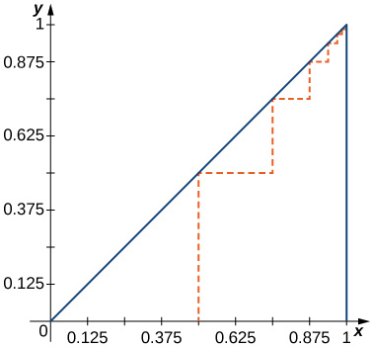

Answer: 

137. **[T]** The Sierpinski gasket is obtained by dividing the unit square into nine equal sub-squares, removing the middle square, then doing the same at each stage to the remaining sub-squares. The figure shows the remaining set after four iterations. Compute the total area removed after  stages, and compute the length the total perimeter of the remaining set after  stages.



Answer: At stage one a square of area  is removed, at stage  one removes squares of area  at stage three one removes  squares of area  and so on. The total removed area after  stages is 

as  The total perimeter is 

**Student Project**

**Euler’s Constant**

1. Let  Evaluate  for various values of 

Answer:      

3. Now estimate how far  is fromfor a given integer  Prove that for   by using the following steps.

1. Show that 
2. Use the result from part a. to show that for any integer 



1. For any integers  and  such that , express  as a telescoping sum by writing



Use the result from part b. combined with this telescoping sum to conclude that



1. Apply the limit to both sides of the inequality in part c. to conclude that



1. Estimateto an accuracy of within 

Answer:

1. 
2. 

Therefore, using the result from a. we conclude that



1. 
2. 

Therefore, 

1. To estimate  to an accuracy of within 0.001, we need to evaluate  

This file is copyright 2016, Rice University. All Rights Reserved.